

SUPERIOR UNIVERSITY LAHORE
GOLD CAMPUS

NAME: MUHAMMAD MOIZ RAZA
ROLL NO: SU92-BSAIM-F24-061
PROGRAM: ARTIFICIAL INTELLIGENCE
SEMESTER: 4th SEMESTER
SECTION: BSAI-4A
SUBJECT: PROGRAMMING OF AI (LAB)

Submission Title: LAB TASK 4
Submitted To: Sir Rasikh Ali

TITLE: N-queens problem solver using recursion and backtracking

OVERVIEW:
In this lab task, we solve the n-queens problem, which involves placing n queens on an n×n chessboard so that no two queens can attack each other. the program uses recursion and backtracking to explore different arrangements and find all possible solutions.

Technologies Used
python
recursion and backtracking algorithm
Working:
the program starts at the first row and tries to place a queen in each column. it checks for conflicts with queens already on the board and only places a queen in a safe spot. when all rows are filled without conflicts, the arrangement is saved as a solution. the program backtracks when it hits an unsafe position to try other possibilities. finally, it prints all valid solutions and their total count.
Uses:
This task helps students understand recursion, backtracking, and problem-solving with constraints. it is often used in computer science labs to learn algorithm design and logical thinking.

Screenshot:
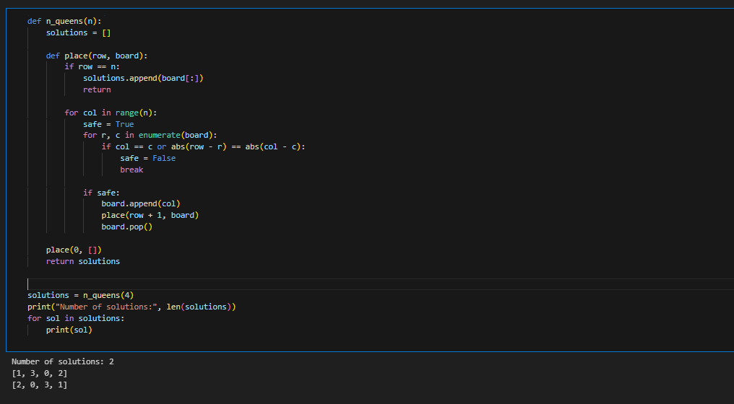

THE END

